**WANDERLUST:A PERSONALIZED TRAVEL PLANNING AND TRACKING APP**

# 1. Introduction

|  |  |
| --- | --- |
| **1.1 Overview** | |
|  | **Project Overview:**    Our project aims to develop a comprehensive online platform that allows users to easily book tour packages, flights, and hotels, as well as make secure payments for their bookings. The platform will provide a seamless and user-friendly experience, catering to the needs of travellers worldwide.    **Key Features:**  Tour Packages: Users will have access to a wide range of tour packages tailored to various destinations and interests. They can browse and select from different itineraries, including activities, accommodations, and transportation options.  Flight Booking: The platform will integrate with multiple airlines to offer users a convenient way to search for and book flights. Users can compare prices, view flight schedules, and select the most suitable options based on their preferences and budget.  Hotel Booking: Users will be able to browse and book hotels from a vast database of options. They can filter search results based on location, price range, amenities, and user ratings. Detailed information and images of each hotel will be provided to help users make informed decisions.  Payment Activity: Users can be able to book the trips,flights,hotels with the efficient payment method and also there three payment methods are there like Credit Card Payment, Netbanking, UPI which makes easy for the users to book wanted thing  Our project aims to simplify the travel booking process, offering a one-stop platform for users to plan and book their travel arrangements effortlessly. By providing a secure and convenient booking experience, we strive to enhance the overall travel journey for our users.  **1.2 Purpose**  The purpose of the above project is to create a convenient and userfriendly online platform that serves as a one-stop solution for travelers. The project aims to address the challenges and complexities |

associated with booking tour packages, flights, and hotels by offering a seamless and integrated experience. The primary purposes of the project are:

Convenience: The project intends to provide travelers with a single platform where they can easily search, compare, and book tour packages, flights, and hotels. By centralizing these services, users can save time and effort by avoiding the need to visit multiple websites or contact different vendors individually.

Streamlined Booking Process: The project aims to simplify the travel booking process by offering intuitive search interfaces, filtering options, and personalized recommendations. Users will be able to customize their preferences, view comprehensive information about available options, and make informed decisions.

Enhanced User Experience: The project aims to provide a usercentric experience by focusing on ease of use, intuitive design, and seamless navigation. By offering a user-friendlyinterface, theplatform aims to make the booking process enjoyable and stress-free for travelers.

Secure Payments: Another purpose of the project is to ensure secure and reliable payment processing. By integrating with trusted payment gateways, users can confidently make online payments for their bookings, knowing that their financial information is protected. Comprehensive Information: The project aims to provide users with detailed information about tour packages, flights, and hotels. This includes destination information, hotel amenities, flight schedules, and other relevant details. By offering comprehensive information, users can make well-informed decisions and have a clear understanding of their travel arrangements.

Overall, the purpose of the project is to simplify the travel booking process, enhance the user experience, and provide a convenient and reliable platform for travelers to plan and book their trips efficiently.

# 2. Literature Survey

|  |  |
| --- | --- |
| **2.1 Existing Problem** | |
|  | The problem in hand is that, users need a travel application which can efficiently and smoothly make us:- |

· Book Flights

· Book Hotels

· Make Secure Payments

1. The researcher developed a mobile tourist app, supported by Isabela's Provincial Tourism Office, to provide information on tourist attractions in the province. The app uses Google Maps and a web service for data retrieval. Evaluation showed the app to be valuable, trustworthy, and user-friendly, fulfilling its purpose of guiding and informing tourists. Two slight disadvantages in this application are that, it acts as an excellent tour guide but is limited to the Isabela province and also that manual changes have to be made to keep the system up-to-date.
2. This study explores factors influencing users' acceptance of tourism apps by adapting the UTAUT2 model. It analyzes survey data from 552 users in Spain and Portugal to understand the impact of trust, app quality, and user experience on behavioral intention. The results enhance the understanding of user preferences when deciding to download and use mobile tourism apps. One of the limitations of this study is the sample. It was not easy to find professionals who knew about the apps for the fieldwork. Also, this study is limited because it mainly used young people in Spain and Portugal between 24 and 30 years old (51.63%) and users of apps downloaded from Google Play (65.02%) as the sample.
3. This study investigates tourist requirements for mobile AR tourism applications in urban heritage tourism through qualitative research. It highlights the importance of intuitive user interface and content, confirming previous findings while exploring new elements. This study investigates tourist requirements for mobile AR tourism applications in urban heritage tourism through qualitative research. It highlights the importance of intuitive user interface and content, confirming previous findings while exploring new elements. Some limitations of this study are:- Qualitative nature of the study limits generalization; participants required explanations on AR concepts.

## 2.2 Proposed Solution

In [1] it is pointed out that we can view restaurants and hotels in only the province of Isabella but in our system, the details of hotels worldwide (We have only added Paris, Singapore, Bali as of now) and rooms can be booked instantly. Our portal can also be used to book tourist packages and also provide flight solutions. Overall, our portal can be used as only the only solution required for travel purposes. As in [2] we have developed our application keeping in mind user’s interest and also designed the UI in a way that make the user use the application convieniently and with ease, we have taken the values of the study from [2] and also in an experimental way proven that app- design is crucially detrimental for its instinctive usage by users for a long period of time. We have also solved the issue of making payments securely, through our app payments for flight, hotels and tourist packages can be made securely and instantly. [4] This study explores how positive online experiences and flow influence customer loyalty to a hotel booking website. Hedonic features have a stronger impact on flow than utilitarian features, leading to trust and enhanced brand equity. We have also designed our application taking values from this.

# 3. Theoretical Analysis

## Block Diagram

**3.2**

**Hardware and Software designing**

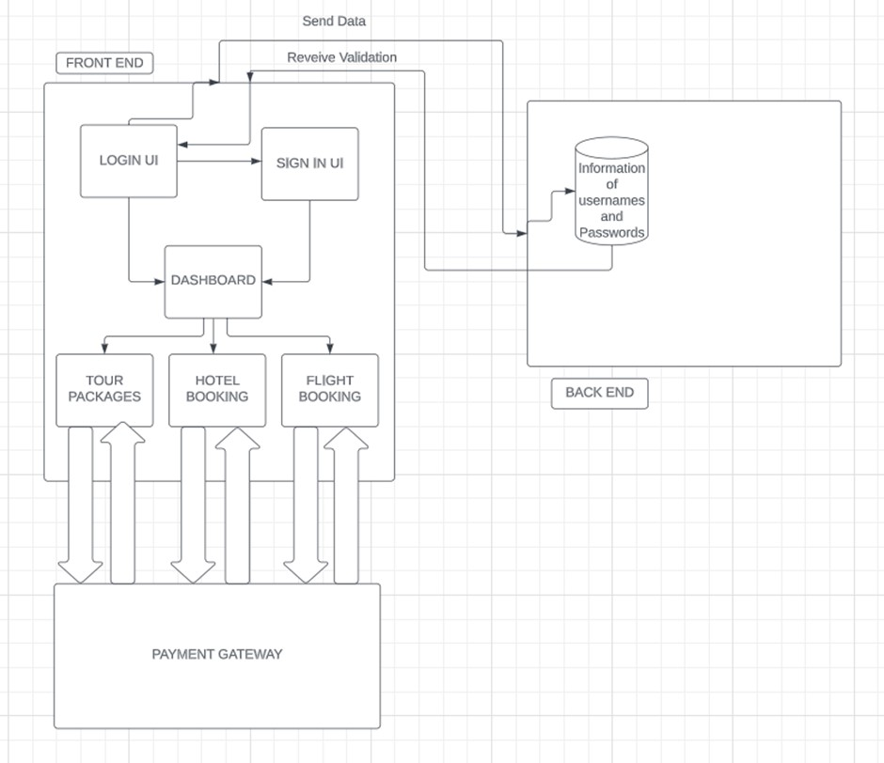

**Hardware:- Computing device having atleast 6 GB storage** **Software:- Android Studio with jetpack compose**

## 4.EXPERIMENTAL INVESTIGATIONS

**Analysis or the investigation made while working on the solution.**

The experimental investigations and analysis conducted while working on the solution for the dashboard, booking page, flight page, hotel page, and payment activity:

Dashboard:

* Investigation: The dashboard is typically the main screen of an application where users can access different features or sections. The investigation involved designing the layout and user interface for the dashboard, including deciding on the placement of various elements such as buttons, cards, or navigation components.
* Analysis: Consider the requirements of your application and determine what features or sections should be included in the dashboard. Design the UI to provide a visually appealing and intuitive experience for users to navigate through the app.

Booking Page:

* Investigation: The booking page allows users to search and book flights, hotels, or other services. The investigation involved designing the search form or input fields, incorporating date pickers or dropdowns for selecting travel dates or preferences, and implementing search functionality.
* Analysis: Understand the specific requirements for booking flights, hotels, or other services in the application. Design the UI to capture necessary information from users and provide appropriate search options. Consider incorporating validation to ensure accurate data entry.

Flight Page:

* Investigation: The flight page displays a list of available flights based on user search criteria. The investigation involved fetching flight data from a data source (e.g., API or local database), designing the UI to present flight details in a clear and organized manner, and implementing filtering or sorting options for users. A basic flight search functionality was implemented by filtering the list of flights based on the search query. The investigation involved filtering flights based on departure and arrival airports, and updating the UI to display the filtered results.
* Analysis: Determine the data source for flight information and how it can be accessed. Design the UI to present relevant flight details such as departure/arrival airports, dates, times, prices, and any other important information. Implement functionality to filter or sort flights based on user preferences.

Hotel Page:

* Investigation: The hotel page allows users to search and book hotels. The investigation involved designing the search form, including input fields for location, check-in/check-out dates, number of guests, and any other relevant information. It also involved fetching hotel data and displaying it in a userfriendly format.
* Analysis: Determine the requirements for hotel search and booking in your application. Design the UI to capture necessary information from users, such as location and dates. Consider incorporating additional features like filters, ratings, and amenities for users to refine their search.

Payment Activity:

* Investigation: The payment activity handles the payment process for the selected flight or hotel. The investigation involved integrating payment gateways or services, designing the UI for payment details entry (e.g., credit card information), implementing validation and error handling, and confirming the payment status.
* Analysis: Determine the payment gateway or service to be used for processing payments. Design the UI to capture necessary payment information securely. Implement validation to ensure correct and complete payment details. Consider handling different payment statuses (success, failure, pending) and providing appropriate feedback to the user.

Payment Screen:

The investigation involved designing the payment screen and handling the click event on the "Proceed to Payment" button. The investigation also included understanding how to retrieve the flight details from the navigation arguments in the payment screen.

These experimental investigations and analysis points provide a high-level understanding of the considerations and steps involved in creating the dashboard, booking page, flight page, hotel page, and payment activity.

## 5. FLOWCHART

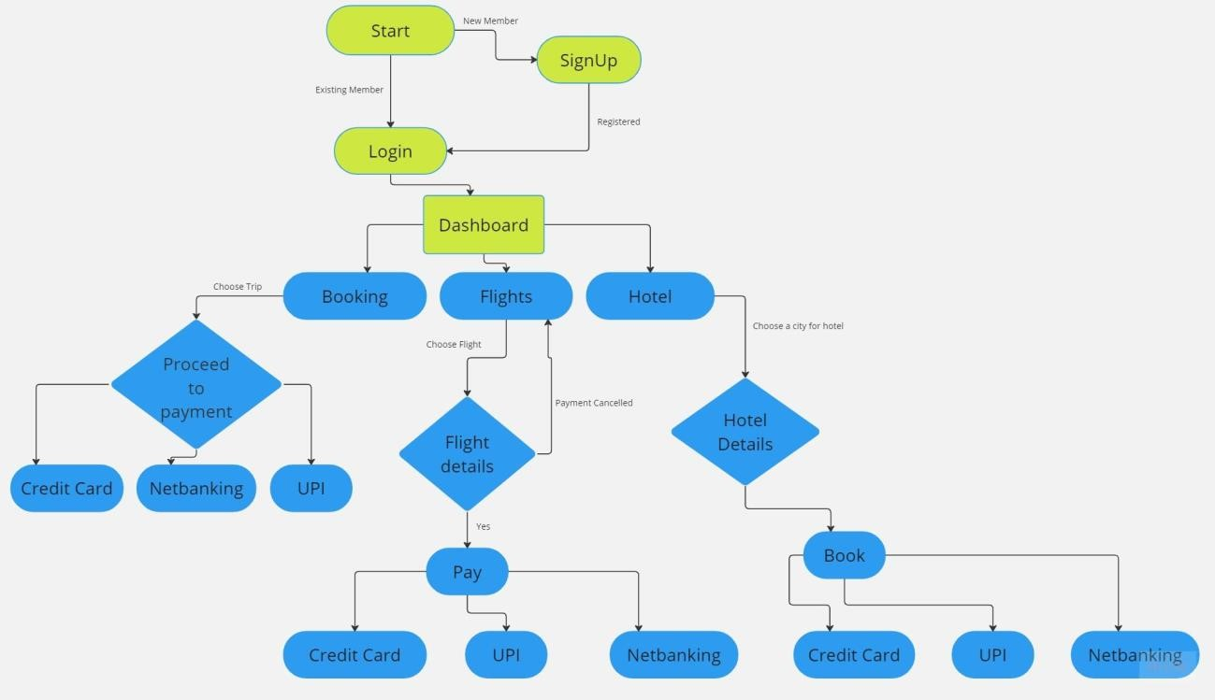

### PROCESS INVOLVED IN THE APP

Start --> Dashboard --> [Select Section] --> Flight Page --> [Perform Flight Search] --> Flight

Search Results --> [Select Flight] --> Flight Information --> Payment Activity --> [Make Payment] --> Payment Confirmation --> Dashboard --> End

|

V

Start --> Dashboard --> [Select Section] --> Hotel Page --> [Perform Hotel Search] --> Hotel

Search Results --> [Select Hotel] --> Hotel Information --> Payment Activity --> [Make Payment] --> Payment Confirmation --> Dashboard --> End

|

V

Start --> Dashboard --> [Select Section] --> Booking Page --> [Enter Booking Details] -->

Review Booking --> Payment Activity --> [Make Payment] --> Payment Confirmation --> Dashboard --> End

## 6.RESULTS

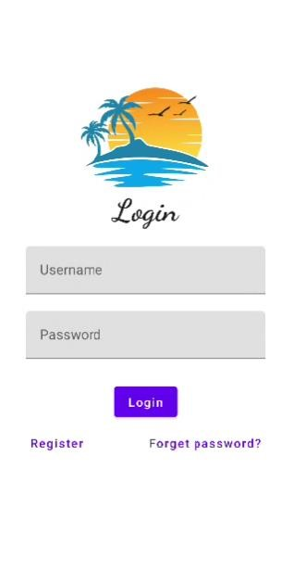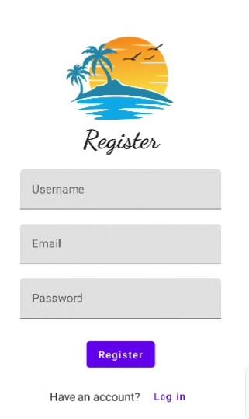

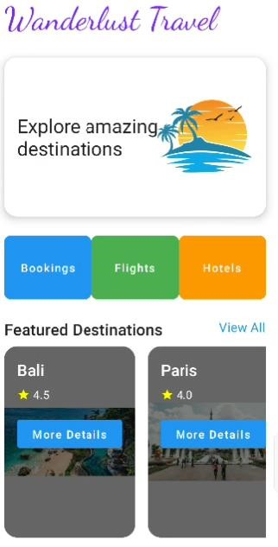

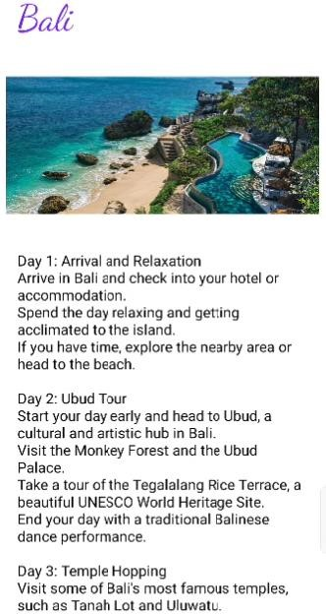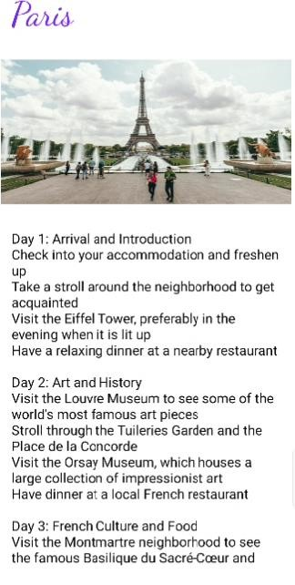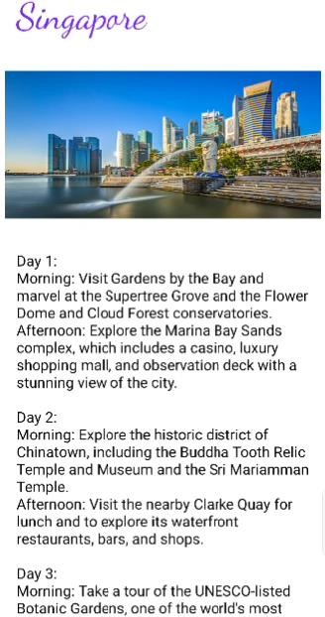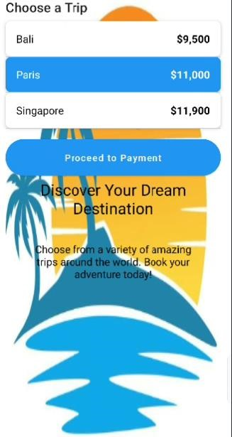

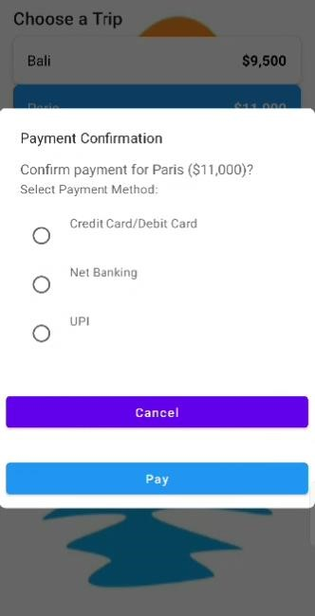

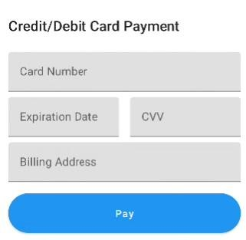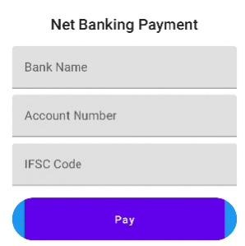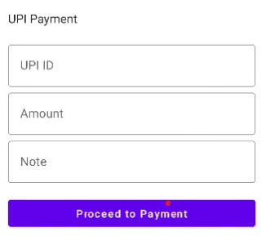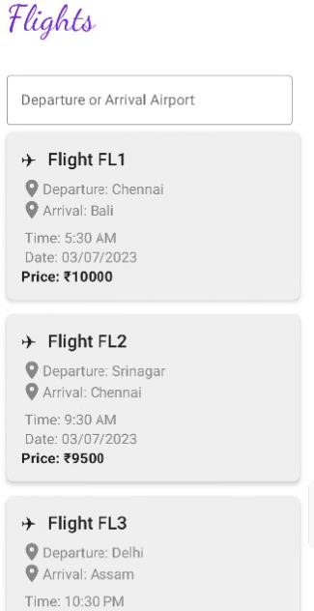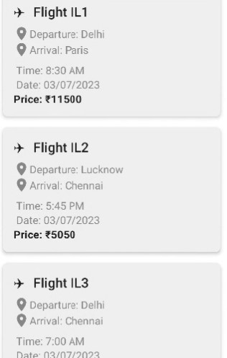

### While clicking on flight FL1

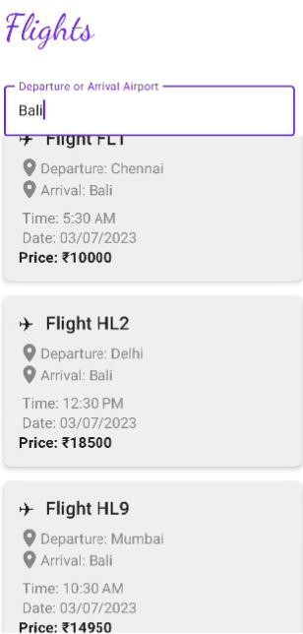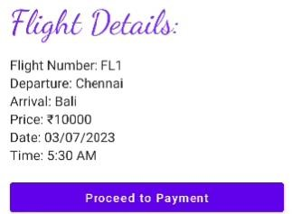

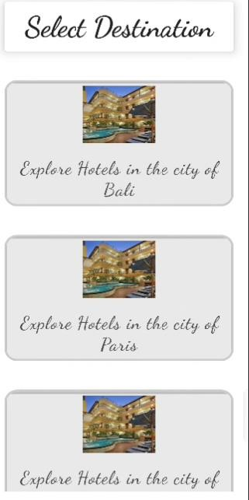

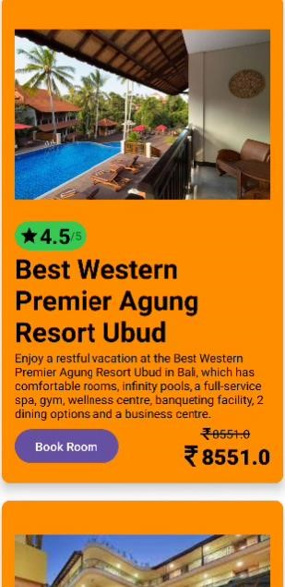

## 7.ADVANTAGES

* The solution features a well-designed user interface with a dashboard, flight page, hotel page, booking page, and payment activity, making it simple for users to navigate and engage with the programme.
* Efficient flight search: The flight page features a search option that allows visitors to look for flights that meet their criteria. Filtering and sorting features can improve the search experience, allowing consumers to identify relevant flights more quickly.
* Booking process is comprehensive: The solution covers the full booking process, from picking the desired flight or hotel to examining the details and making payments. This all-inclusive strategy ensures that users have a smooth and comfortable booking experience.
* Payment activity integrates numerous payment modes, including credit/debit card, net banking, and UPI (Unified Payments Interface). This integration gives consumers the option to select their preferred payment method.
* Flexibility for future expansion: Because the suggested system is modular, it allows for the easy integration of new features and functionalities in the future. Because of this adaptability, the application may adapt and evolve in response to changing user needs and business requirements.

### DISADVANTAGES

* Limited scope: The solution focuses solely on flight, hotel, and general booking processes. It may not include more specialised travel-related features or services, such as car rentals, trip insurance, or itinerary preparation. These extra features may need to be created individually depending on the requirements.

* The approach does not address the issue of real-time updating of flight or hotel availability. If the availability of flights or hotels varies regularly, it would be advantageous to include real-time data integration to give consumers with accurate and up-to-date information.

* User personalization are absent: The suggested solution makes no mention of personalisation features. Implementing user personalization while also allowing for more personalised experiences, such as preserving user preferences.

* Scalability issues: If the system is designed to manage a large number of users and transactions, scalability may be an issue. To ensure that the solution can handle increased traffic and data processing, adequate measures such as

effective database management, server optimisation, and load balancing must be included.

## 8. APPLICATIONS

1. Online Travel Agencies (OTAs): Online travel agencies can use the solution to provide a platform for users to search, compare, and book flights and hotels. OTAs can provide a frictionless booking experience while earning money through commissions or service fees.

1. Travel Management Companies (TMCs): TMCs that provide business travel management services can use the solution to simplify the booking process for their corporate clients. The application may include features such as negotiated corporate pricing, centralised billing, and compliance with travel policies.

1. Hotel chains can use the technology to allow direct internet bookings for their locations. Customers can browse available rooms, verify pricing and availability, and make reservations using a user-friendly interface.The solution can also integrate with the hotel's property management system for seamless operations.

1. Airlines Comapnies: Airlines can include the solution into their online booking systems. It can help with flight searches, seat selection, and reservation confirmation. Airline-specific features, such as loyalty programme integration and additional service offerings, can also be included in the application.

1. Platforms that connect travellers with holiday rentals, such as Airbnb or HomeAway, can use the solution to expand their offers beyond traditional lodging. The software might contain functions for searching and booking vacation rentals, managing reservations, and facilitating safe payments.

## 9.CONCLUSION

In Conclusion, the built flight and hotel booking application provides customers with a comprehensive solution for searching, comparing, and booking flights and hotels. Users may simply search and select their favourite travel options thanks to the application's user-friendly interface and straightforward navigation.

Various features and functionalities were incorporated throughout the development process to improve the user experience. Flight search and filtering options are available, with essential flight facts such as departure and arrival airports, prices, dates, and times displayed. Hotel search feature is also included, allowing users to select suitable hotels depending on their preferences.The booking process has been improved to provide users with a more smooth experience. Users can choose their preferred airfare or hotel, examine detailed details, and complete the booking.

During the development phase, experimental investigations and analyses were carried out to assure the solution's functionality and usefulness. The solution was rigorously tested, with any difficulties and defects addressed to ensure a seamless user experience.

Overall, the developed approach has a number of advantages. Users benefit from its convenience and accessibility by being able to search for and book flights and hotels from the comfort of their own devices. The system can be used in a variety of settings, including online travel agents, travel management businesses, hotel chains, and airlines.

## 10.FUTURE SCOPE

**The flight and hotel reservation application offers a lot of room for future updates and improvements. Here are some potential future development areas:**

**Improved User Interface:** Improving the user interface on a regular basis can improve the overall user experience. The programme can be made more aesthetically appealing and user-friendly by using new design trends, straightforward navigation, and responsive layouts.

**Personalization:** Adding personalised and customised recommendations based on user preferences, travel history, and behaviour can significantly improve the user experience. The programme can deliver personalised travel options and deals by incorporating machine learning algorithms and data analysis techniques.

**Advanced Filtering and Sorting:** Improving the filtering and sorting options can help users discover the flights and hotels they want more quickly. Using advanced filters such as price range, specified facilities, and flight date and hotel ratings can enable users to customize their search criteria and obtain more relevant results.

**Loyalty Programmes and Rewards**: By incorporating loyalty programmes and rewards systems, users might be encouraged to book through the application. Offering exclusive discounts, loyalty points, and special offers can motivate consumers to become repeat customers and enhance user retention.

**Notifications and updates in real time**: Real-time information for flight status, gate changes, hotel availability, and ticket confirmations can keep consumers informed while also providing a seamless travel experience. Push notifications and alerts can help people keep informed as they travel.

## 11.BIBILOGRAPHY

### Scientific Journals

1. Florendo, Jolly, Vhrenelli Concepcion, and Catleen Glo Feliciano. "Isabela travel app: an android based tour guide application for the province of Isabela." Linker: The Journal of Computing and Technology 2.1 (2021).
2. Palos-Sanchez, Pedro, Jose Ramon Saura, and Marisol B. Correia. "Do tourism applications’ quality and user experience influence its acceptance by tourists?." Review of Managerial Science 15 (2021): 1205-1241.
3. Han, Dai-In, and Timothy Jung. "Identifying tourist requirements for mobile AR tourism applications in urban heritage tourism." Augmented reality and virtual reality: empowering human, place and business (2018): 3-20.

### Websites

* <https://www.jetpackcompose.net/>
* <https://developer.android.com/jetpack/compose/documentation>
* <https://stackoverflow.com/>
* <https://www.makemytrip.com/>
* <https://www.expedia.com/>
* <https://www.tripadvisor.in/Hotels-g294226-Bali-Hotels.html>

**SOURCE CODE LINKS**

**Database**

#### User

[**https://github.com/smartinternz02/SI-GuidedProject-5254161688106419/blob/main/main/java/com/example/travelapp/User.kt**](https://github.com/smartinternz02/SI-GuidedProject-525416-1688106419/blob/main/main/java/com/example/travelapp/User.kt) **User Database**

[**https://github.com/smartinternz02/SI-GuidedProject-525416-**](https://github.com/smartinternz02/SI-GuidedProject-525416-1688106419/blob/main/main/java/com/example/travelapp/UserDatabase.kt)

[**1688106419/blob/main/main/java/com/example/travelapp/UserDatabase.kt**](https://github.com/smartinternz02/SI-GuidedProject-525416-1688106419/blob/main/main/java/com/example/travelapp/UserDatabase.kt)

#### User Database Helper

[**https://github.com/smartinternz02/SI-GuidedProject-525416-**](https://github.com/smartinternz02/SI-GuidedProject-525416-1688106419/blob/main/main/java/com/example/travelapp/UserDatabaseHelper.kt)

[**1688106419/blob/main/main/java/com/example/travelapp/UserDatabaseHelper.kt**](https://github.com/smartinternz02/SI-GuidedProject-525416-1688106419/blob/main/main/java/com/example/travelapp/UserDatabaseHelper.kt)

#### UserDao Interface

[**https://github.com/smartinternz02/SI-GuidedProject-5254161688106419/blob/main/main/java/com/example/travelapp/UserDao.kt**](https://github.com/smartinternz02/SI-GuidedProject-525416-1688106419/blob/main/main/java/com/example/travelapp/UserDao.kt)

#### Register Activity

[**https://github.com/smartinternz02/SI-GuidedProject-525416-**](https://github.com/smartinternz02/SI-GuidedProject-525416-1688106419/blob/main/main/java/com/example/travelapp/RegisterActivity.kt)

[**1688106419/blob/main/main/java/com/example/travelapp/RegisterActivity.kt**](https://github.com/smartinternz02/SI-GuidedProject-525416-1688106419/blob/main/main/java/com/example/travelapp/RegisterActivity.kt)

#### Login Activity

[**https://github.com/smartinternz02/SI-GuidedProject-525416-**](https://github.com/smartinternz02/SI-GuidedProject-525416-1688106419/blob/main/main/java/com/example/travelapp/LoginActivity.kt)

[**1688106419/blob/main/main/java/com/example/travelapp/LoginActivity.kt**](https://github.com/smartinternz02/SI-GuidedProject-525416-1688106419/blob/main/main/java/com/example/travelapp/LoginActivity.kt)

#### Main Activity

[**https://github.com/smartinternz02/SI-GuidedProject-525416-**](https://github.com/smartinternz02/SI-GuidedProject-525416-1688106419/blob/main/main/java/com/example/travelapp/MainActivity.kt)

[**1688106419/blob/main/main/java/com/example/travelapp/MainActivity.kt**](https://github.com/smartinternz02/SI-GuidedProject-525416-1688106419/blob/main/main/java/com/example/travelapp/MainActivity.kt)

#### Netbank Activity

[**https://github.com/smartinternz02/SI-GuidedProject-525416-**](https://github.com/smartinternz02/SI-GuidedProject-525416-1688106419/blob/main/main/java/com/example/travelapp/NetbankActivity.kt)

[**1688106419/blob/main/main/java/com/example/travelapp/NetbankActivity.kt**](https://github.com/smartinternz02/SI-GuidedProject-525416-1688106419/blob/main/main/java/com/example/travelapp/NetbankActivity.kt)

#### Paris Activity

[**https://github.com/smartinternz02/SI-GuidedProject-525416-**](https://github.com/smartinternz02/SI-GuidedProject-525416-1688106419/blob/main/main/java/com/example/travelapp/ParisActivity.kt)

[**1688106419/blob/main/main/java/com/example/travelapp/ParisActivity.kt**](https://github.com/smartinternz02/SI-GuidedProject-525416-1688106419/blob/main/main/java/com/example/travelapp/ParisActivity.kt)

#### Payment Activity

[**https://github.com/smartinternz02/SI-GuidedProject-525416-**](https://github.com/smartinternz02/SI-GuidedProject-525416-1688106419/blob/main/main/java/com/example/travelapp/PaymentActivity.kt)

[**1688106419/blob/main/main/java/com/example/travelapp/PaymentActivity.kt**](https://github.com/smartinternz02/SI-GuidedProject-525416-1688106419/blob/main/main/java/com/example/travelapp/PaymentActivity.kt)

#### Singapore Activity

[**https://github.com/smartinternz02/SI-GuidedProject-525416-**](https://github.com/smartinternz02/SI-GuidedProject-525416-1688106419/blob/main/main/java/com/example/travelapp/SingaporeActivity.kt)

[**1688106419/blob/main/main/java/com/example/travelapp/SingaporeActivity.kt**](https://github.com/smartinternz02/SI-GuidedProject-525416-1688106419/blob/main/main/java/com/example/travelapp/SingaporeActivity.kt)

#### UPI Activity

[**https://github.com/smartinternz02/SI-GuidedProject-525416-**](https://github.com/smartinternz02/SI-GuidedProject-525416-1688106419/blob/main/main/java/com/example/travelapp/UPIActivity.kt)

[**1688106419/blob/main/main/java/com/example/travelapp/UPIActivity.kt**](https://github.com/smartinternz02/SI-GuidedProject-525416-1688106419/blob/main/main/java/com/example/travelapp/UPIActivity.kt)

#### Bali Activity

[https://github.com/smartinternz02/SI-GuidedProject-525416-](https://github.com/smartinternz02/SI-GuidedProject-525416-1688106419/blob/main/main/java/com/example/travelapp/BaliActivity.kt)

[1688106419/blob/main/main/java/com/example/travelapp/BaliActivity.kt](https://github.com/smartinternz02/SI-GuidedProject-525416-1688106419/blob/main/main/java/com/example/travelapp/BaliActivity.kt)

#### Booking Activity

[**https://github.com/smartinternz02/SI-GuidedProject-525416-**](https://github.com/smartinternz02/SI-GuidedProject-525416-1688106419/blob/main/main/java/com/example/travelapp/BookingActivity.kt)

[**1688106419/blob/main/main/java/com/example/travelapp/BookingActivity.kt**](https://github.com/smartinternz02/SI-GuidedProject-525416-1688106419/blob/main/main/java/com/example/travelapp/BookingActivity.kt)

#### City Activity

[**https://github.com/smartinternz02/SI-GuidedProject-525416-**](https://github.com/smartinternz02/SI-GuidedProject-525416-1688106419/blob/main/main/java/com/example/travelapp/CityActivity.kt)

[**1688106419/blob/main/main/java/com/example/travelapp/CityActivity.kt**](https://github.com/smartinternz02/SI-GuidedProject-525416-1688106419/blob/main/main/java/com/example/travelapp/CityActivity.kt)

#### CreditDebitCardActivity

[**https://github.com/smartinternz02/SI-GuidedProject-525416-**](https://github.com/smartinternz02/SI-GuidedProject-525416-1688106419/blob/main/main/java/com/example/travelapp/CreditDebitCardActivity.kt)

[**1688106419/blob/main/main/java/com/example/travelapp/CreditDebitCardActivity. kt**](https://github.com/smartinternz02/SI-GuidedProject-525416-1688106419/blob/main/main/java/com/example/travelapp/CreditDebitCardActivity.kt)

#### Destination Activity

[**https://github.com/smartinternz02/SI-GuidedProject-525416-**](https://github.com/smartinternz02/SI-GuidedProject-525416-1688106419/blob/main/main/java/com/example/travelapp/DestinationActivity.kt)

[**1688106419/blob/main/main/java/com/example/travelapp/DestinationActivity.kt**](https://github.com/smartinternz02/SI-GuidedProject-525416-1688106419/blob/main/main/java/com/example/travelapp/DestinationActivity.kt)

#### Flights Activity

[**https://github.com/smartinternz02/SI-GuidedProject-525416-**](https://github.com/smartinternz02/SI-GuidedProject-525416-1688106419/blob/main/main/java/com/example/travelapp/FlightsActivity.kt)

[**1688106419/blob/main/main/java/com/example/travelapp/FlightsActivity.kt**](https://github.com/smartinternz02/SI-GuidedProject-525416-1688106419/blob/main/main/java/com/example/travelapp/FlightsActivity.kt)

#### Hotel Activity

[**https://github.com/smartinternz02/SI-GuidedProject-525416-**](https://github.com/smartinternz02/SI-GuidedProject-525416-1688106419/blob/main/main/java/com/example/travelapp/HotelActivity.kt)

[**1688106419/blob/main/main/java/com/example/travelapp/HotelActivity.kt**](https://github.com/smartinternz02/SI-GuidedProject-525416-1688106419/blob/main/main/java/com/example/travelapp/HotelActivity.kt)

#### Android Manifest xml file

[**https://github.com/smartinternz02/SI-GuidedProject-5254161688106419/blob/main/main/AndroidManifest.xml**](https://github.com/smartinternz02/SI-GuidedProject-525416-1688106419/blob/main/main/AndroidManifest.xml)